Docker Desktop Installation Guide
Guide for downloading and installing Docker Desktop on Windows, Mac, and Linux
for the "Containers and Clouds" course @ SoftUni

Download Docker Desktop on Windows
First, you will need to open the Docker documentation https://docs.docker.com/desktop/.
Choose "Windows" from the menu on the left side of the screen. Before installing make sure that your machine matches the needed requirements to use Docker Desktop.
For example, if you use Windows 10+ you could directly download and install Docker Desktop because the platform runs natively on Windows 10+:
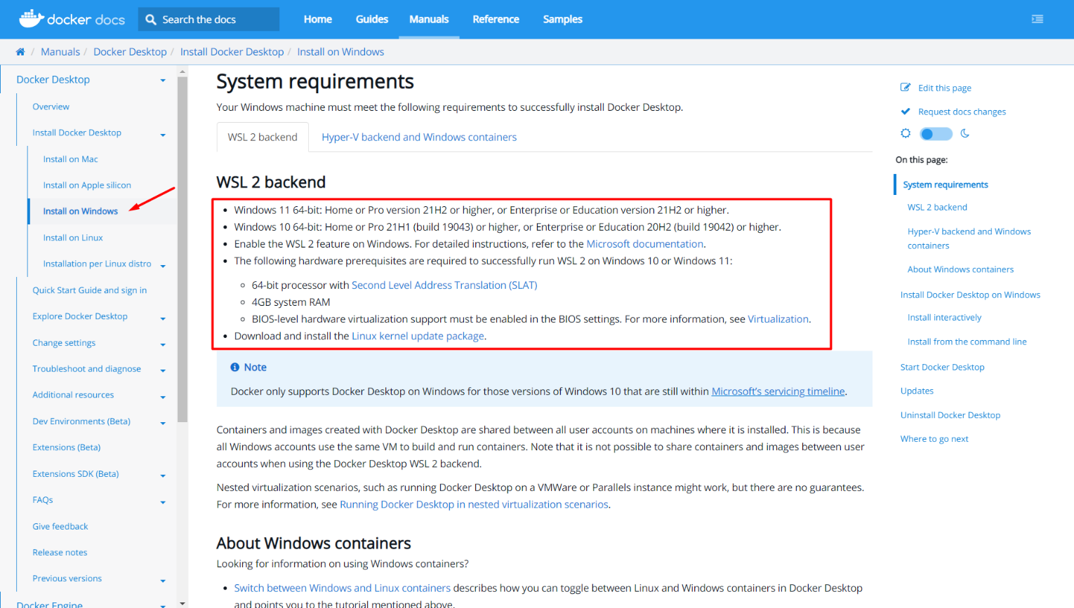
Download the Docker Desktop Installer:
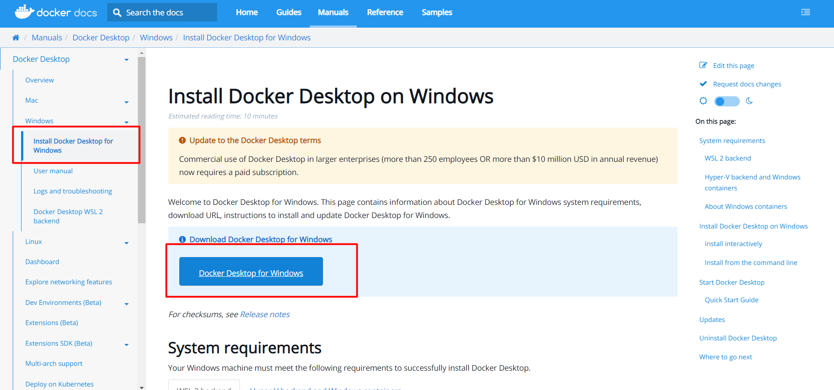
Double-click Docker Desktop Installer.exe to run it (for this example, Docker Desktop 4.10.1 will be installed; you do NOT need to download the same version of the software - it would be best to download the newest one).
When prompted, ensure the "Use WSL 2 instead of Hyper-V" option on the Configuration page is selected or not depending on your choice of backend. If your system only supports one of the two options, you will NOT be able to select which backend to use:
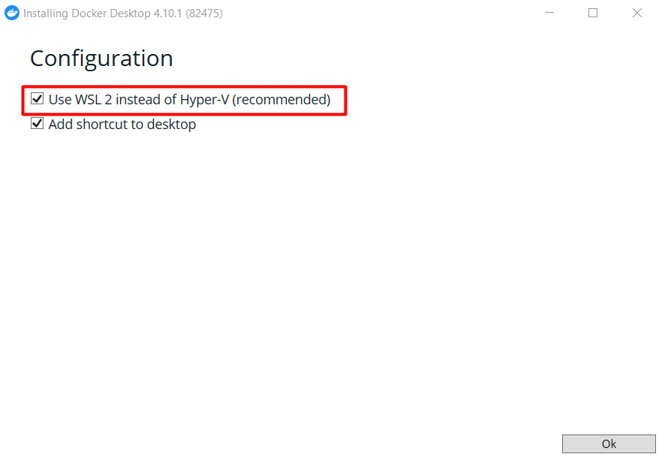
The installation could take couple of minutes:
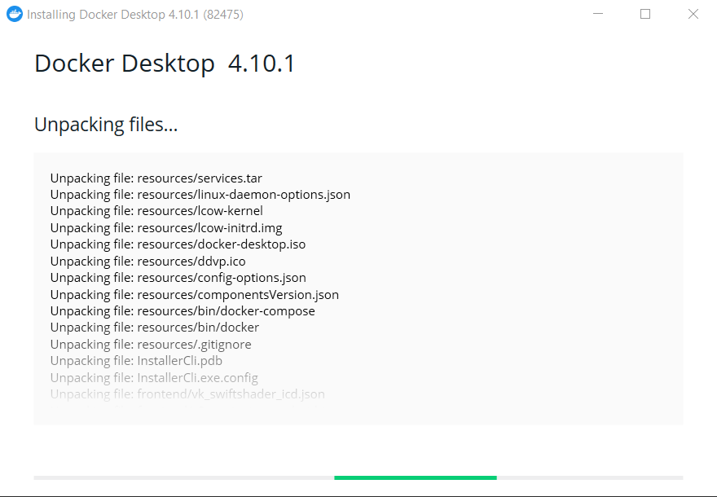
When the installation is successful, click [Close] to complete the installation process:
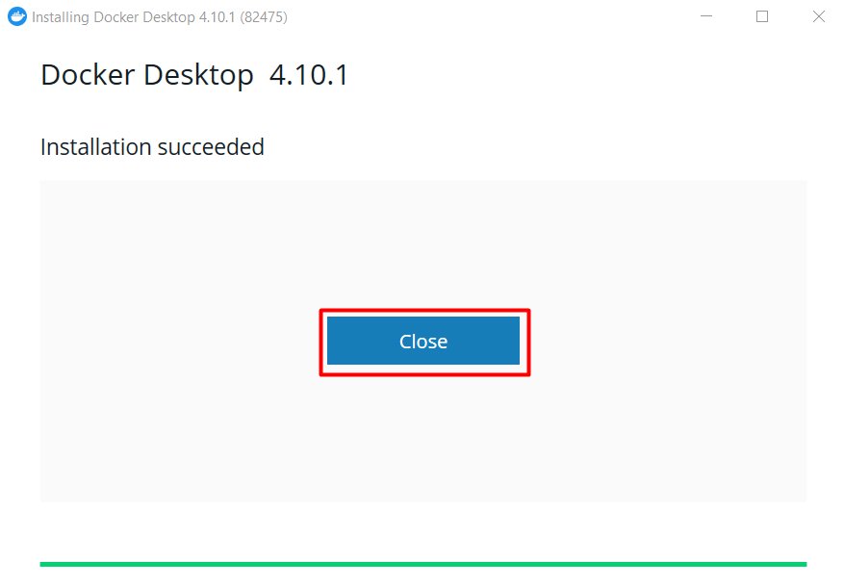
Docker Desktop does NOT start automatically after installation. To start Docker Desktop double-click on the "Docker Desktop" icon. First, it will display the Docker Subscription Service Agreement window. Read the terms and click the checkbox to indicate that you accept the updated terms and then click Accept to continue:
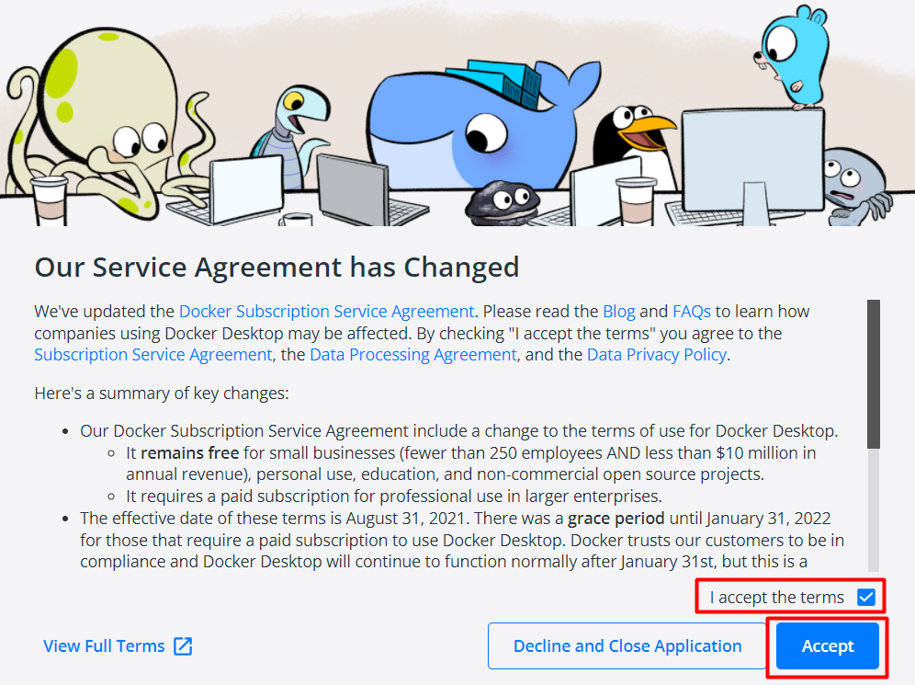
Docker Desktop starts after you accept the terms. You may see the following pop-up message:
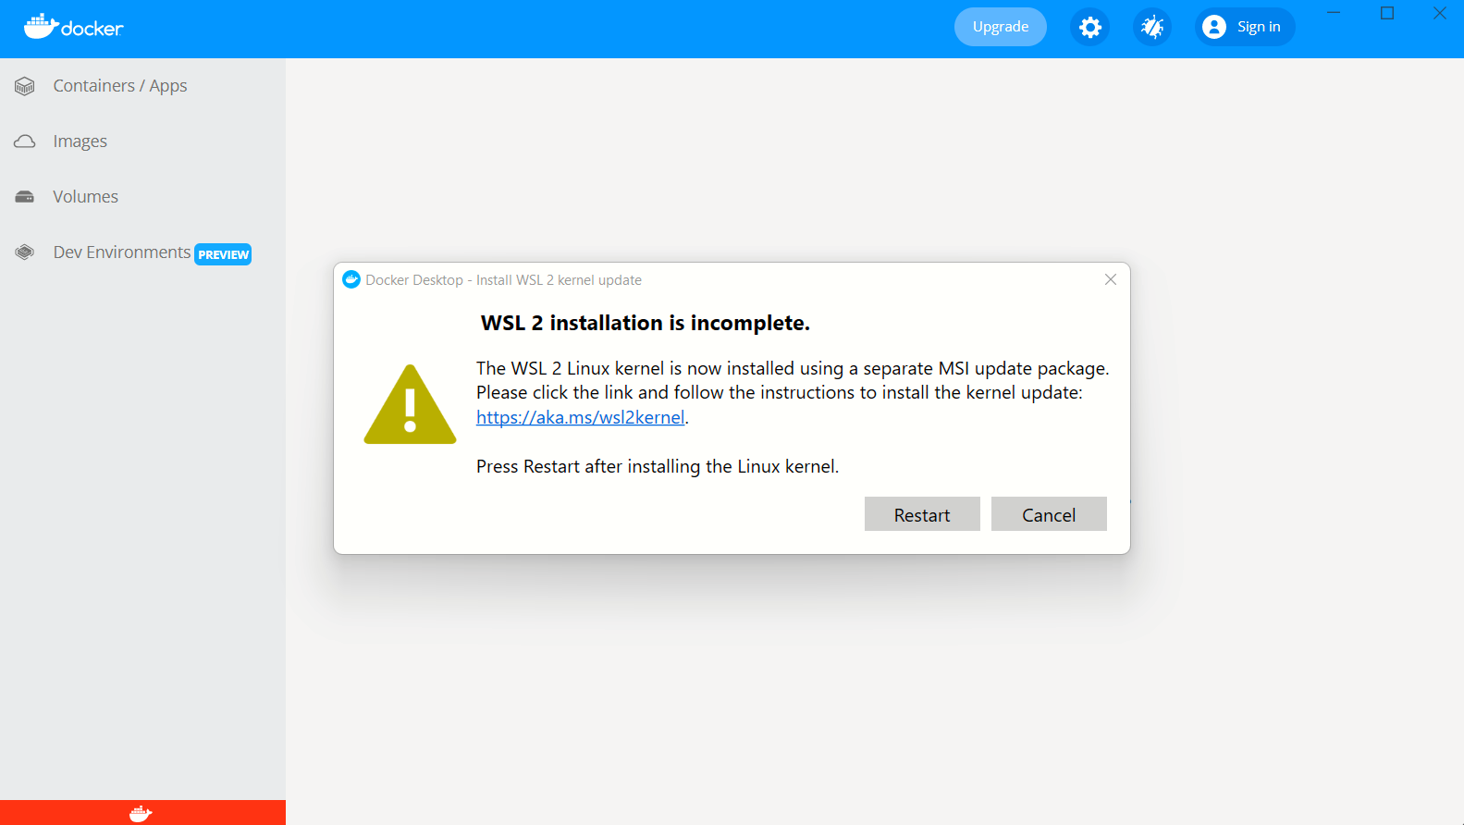
If you do - click on the link, do NOT close the pop-up message, and install the Subsystem for Linux update:
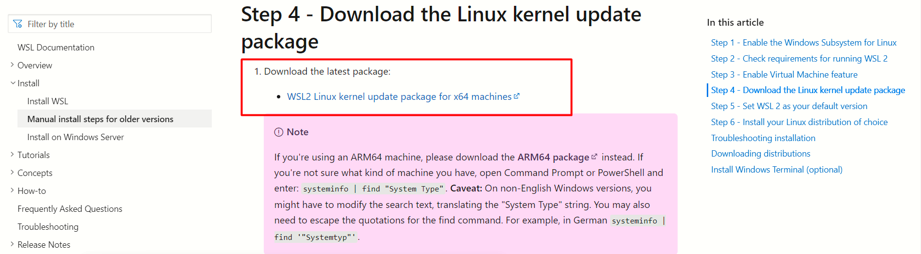
If you installed it correctly, you should see the following window: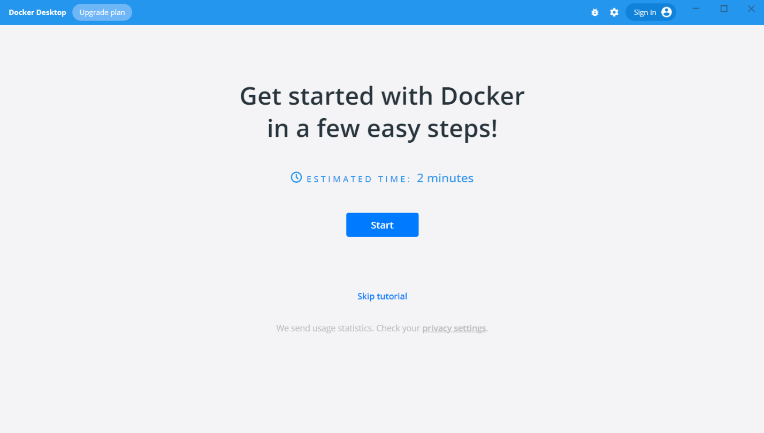
Congratulations! You are now successfully running Docker Desktop on Windows.

Download Docker Desktop on Mac
First, you will need to open the Docker documentation https://docs.docker.com/desktop/.
Choose "Mac" from the menu on the left side of the screen. Before installing make sure that your machine matches the needed requirements to use Docker Desktop.
For example, if you use MacOS 10.15+ you could directly download and install Docker Desktop:
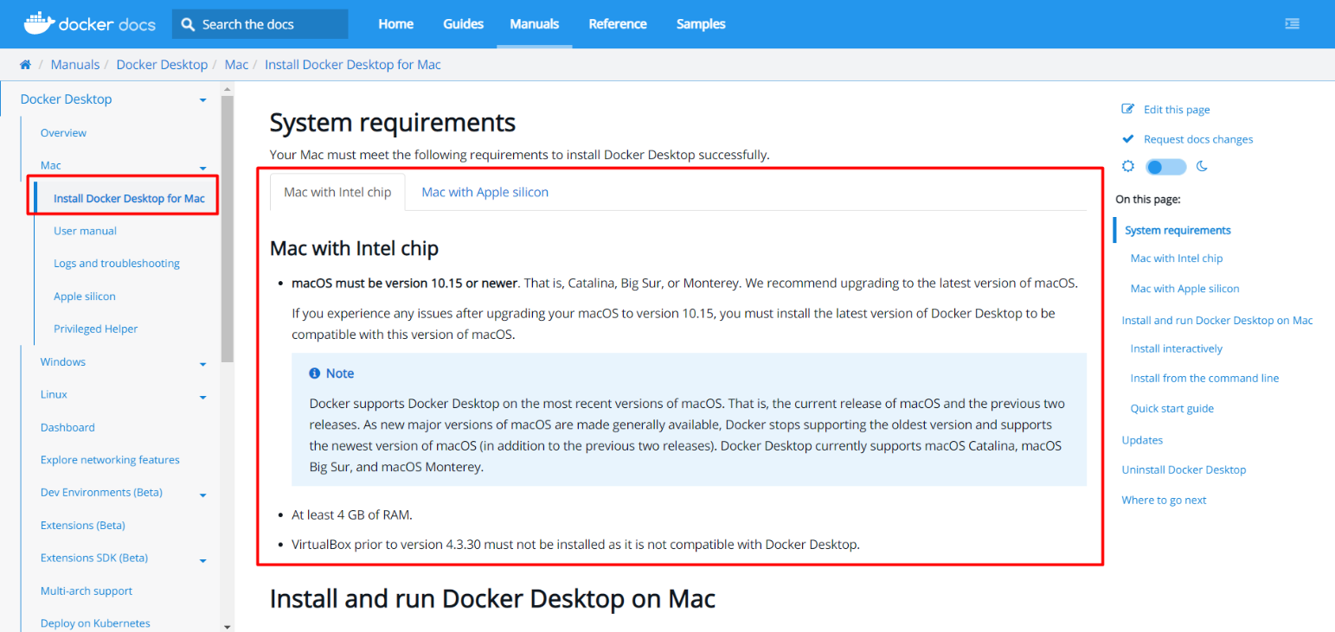
Download the Docker Desktop Installer:
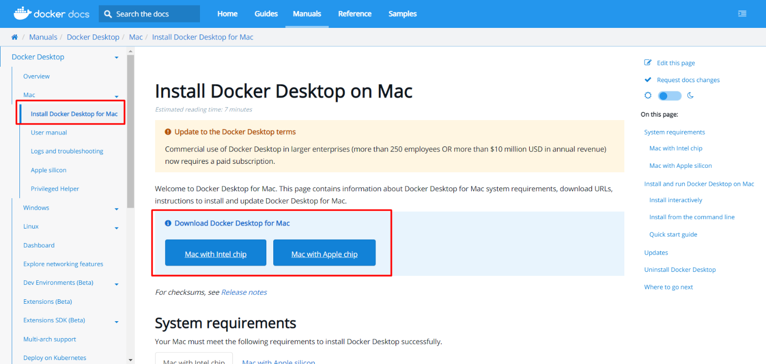
Double-click Docker.dmg to open the installer, then drag the Docker icon to the Applications folder:
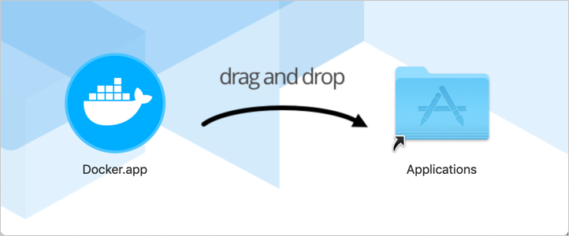
Double-click Docker.app in the Applications folder to start Docker.
First, it will display the Docker Subscription Service Agreement window. Read the terms and click the checkbox to indicate that you accept the updated terms and then click Accept to continue:

If you installed it correctly, you should see the following window: 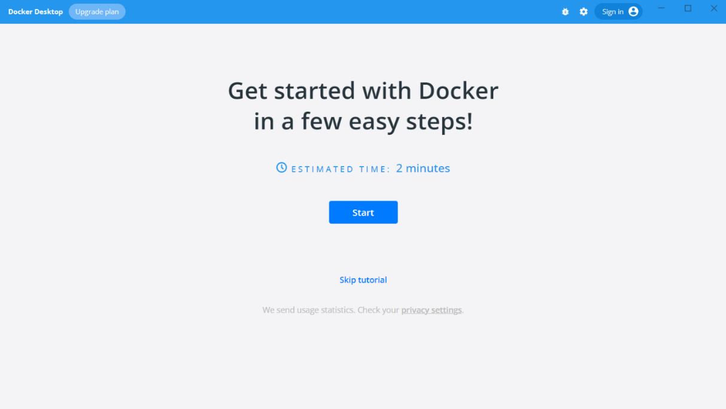
Congratulations! You are now successfully running Docker Desktop on Mac.

Download Docker Desktop on Linux
First, you will need to open the Docker documentation https://docs.docker.com/desktop/.
Choose "Linux" from the menu on the left side of the screen. Before installing make sure that your machine matches the needed requirements to use Docker Desktop.
For example, your Linux distribution should have 64-bit kernel and CPU support for virtualization, KVM virtualization support, and QEMU must be version 5.2 or newer:
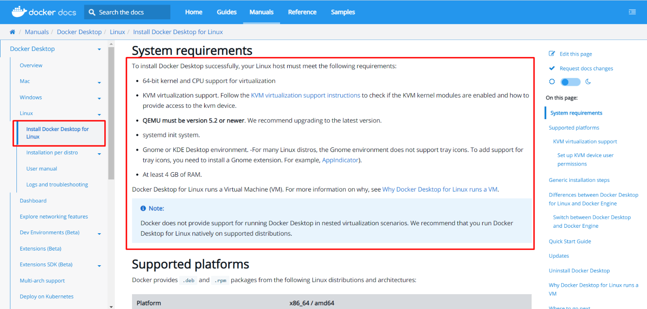
Download the correct package for your Linux distribution and install it with the corresponding package manager:
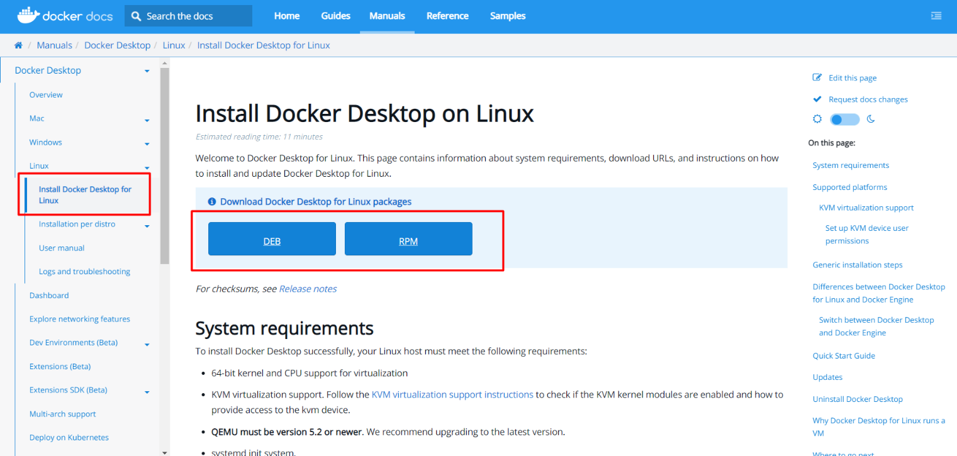
- More on how to install Docker Desktop on Debian: https://docs.docker.com/desktop/linux/install/debian/
- More on how to install Docker Desktop on Fedora: https://docs.docker.com/desktop/linux/install/fedora/
- More on how to install Docker Desktop on Ubuntu: https://docs.docker.com/desktop/linux/install/ubuntu/
- More on how to install Docker Desktop on Arch: https://docs.docker.com/desktop/linux/install/archlinux/
Open your Applications menu in Gnome/KDE Desktop and search for Docker Desktop. Then, select Docker Desktop to start Docker.
First, it will display the Docker Subscription Service Agreement window. Read the terms and click the checkbox to indicate that you accept the updated terms and then click Accept to continue:

If you installed it correctly, you should see the following window:

Congratulations! You are now successfully running Docker Desktop on Linux.

